Practical 7
Implementation of GET and POST Methods using Flask

Steps: -
- Create a file named prac7.py and write the code given below.
- Save the file.
- Open Command Prompt (Terminal) and change the directory to the folder where the Python file is saved.
Example: cd C:\Users\Admin\Desktop\ASH
- In CMD type: python prac7.py
- Now open the links given below in the browser:
Home Page: http://127.0.0.1:5000/
Get All Students: http://127.0.0.1:5000/students
Get Student by ID: http://127.0.0.1:5000/students/1
Add Student: http://127.0.0.1:5000/addstudents?id=5&name=Emma&marks=92

Code: -
from flask import Flask, jsonify, request

app = Flask (__name__)

# Sample Data (dictionary)
students = {
1: {"name": "Alice", "marks": 85},
2: {"name": "Bob", "marks": 90},
3: {"name": "Charlie", "marks": 78}
}

# Home Route
@app.route("/")

def home():
return "Student Marks Web Service Running!"

#Get all students
@app.route("/students", methods = ["GET"])

def get_students():
return jsonify(students)

#Get a student by ID
@app.route("/students/<int:id>", methods = ["GET"])

def get_student(id):
if id in students:
return jsonify(students[id])
return jsonify({"error": "Student not found"}), 404

#Add a student (POST)
@app.route("/students", methods = ["POST"])

def add_student():
data = request.get_json()
sid = data.get("id")
name = data.get("name")
marks = data.get("marks")

students[sid] = {"name": name, "marks": marks}
return jsonify({"message": "Student added successfully!"}), 201

@app.route("/addstudents", methods = ["GET"])

def add_students_get():
sid = request.args.get("id", type=int)
name = request.args.get("name")
marks = request.args.get("marks", type=int)

if not sid or not name or not marks:
return jsonify({"error": "Missing required parameters"}), 400

students[sid] = {"name": name, "marks": marks}
return jsonify({"message": "Student added successfully!"}), 201

#Run Server
if __name__ == "__main__":
app.run(debug = True)

Output: -
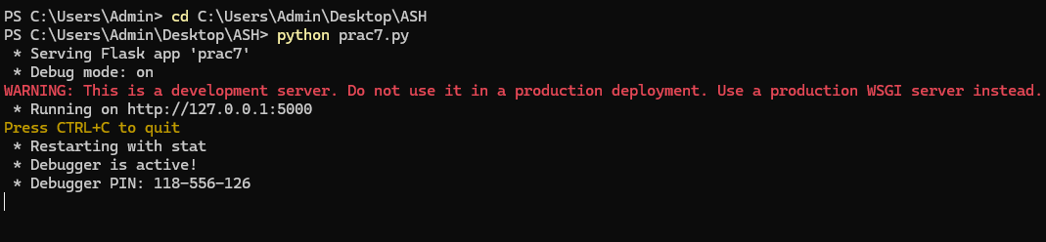
Home Page
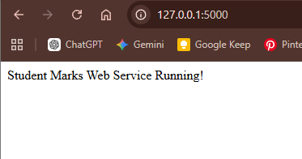

Get All the Students
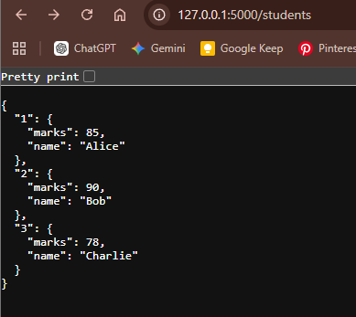

Get Student by ID
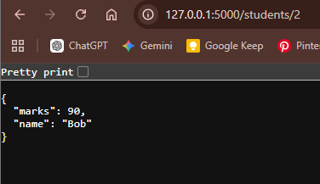

Add Student
